MONDAY | TUESDAY | WEDNESDAY | THURSDAY | FRIDAY
10.15-11.15am  Keep Fit with Liam  £5 max 20 | 10-11am  Tai Chi with Raj  £5 max 20 | 10-12pm NEW  Computer Class – Drop in 30 min slot with an IT expert  £5 | 10.15-11.15pm  Keep Fit with Liz  £5 max 20 | 9.30-12.30 NEW  Sewing lessons with Zoe  £15 max 8  Book direct on 07877223241
11.30-12.30pm  Cognitive Exercise with Liam  £5 max 15 | 11.45-12.45pm  Keep Fit with Liam  £5 max 20 | 11.15-12.15  Line Dancing  £5 max 15 | 11.30-12.15pm NEW  Supportive yoga with chairs Carmen  £5 max 20
3-3.45pm  Keep Steady with Active Life  £5 max 20 | 1-2pm NEW  Gentle Yoga with Claire M  £5 max 20 | 7-8pm NEW  Advanced Martial Arts Training  £5 max 20  Book direct 07543696517 | 12.30-1.30pm  Strollercise  £5 max 15
4.15-5pm  Pilates with Active Life  £5 max 20 | 3.30-5pm COMING SOON  Art Classes  £5 max 20 |  | 2-3pm NEW  Beginners Belly Dancing  £5 max 15
6-6.45pm NEW
Zumba with Fern
£5 max 20
Book Direct on 07912090963
7-8pm NEW
Yoga with Carmen
£5 max 20
Book Direct on 07974348040
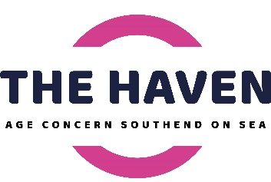
To Book email bookings@acsos.co.uk or call 07835942365 Please book at least 2 days in advance. Payment on booking required.
Follow us on The Haven Community Hub @thehavencommunityhub The Haven Community Hub
Classes held at The Haven Community Hub (Havens Department Store), 138-140 Hamlet Court Road, Westcliff, SS07LW

To book email bookings@acsos.co.uk or call 07835942365 Please book at least 2 days in advance. Payment on booking required. Classes held at 138-140 Hamlet Court Road, SS07LW.
All exercise classes are upstairs. No lift available at present. Please bring your own mat although we have a small number available to purchase. For exercise classes, please wear a mask and remove once you are on your mat. All other classes please wear a mask throughout. This is a covid secure venue, please follow all protocols in place and maintain social distancing.

